A

MAJOR PROJECT REPORT
ON
AN INVESTIGATION OF SOCIAL MEDIA USAGE AND ITS IMPACT ON STUDENT’S EXPOSE TO CYBERCRIMES IN INDIA
Submitted in partial fulfillment for the award of the degree of

BACHELOR OF TECHNOLOGY
in
COMPUTER SCIENCE AND ENGINEERING
By

MOTHUKU MOUNIKA - 21Q91A05H1
Under the guidance of
Dr. G MANJUNATH

HEAD OF DEPERTMENT

DEPARTMENT OF COMPUTER SCIENCE AND ENGINEERING
MALLA REDDY COLLEGE OF ENGINEERING
(Approved by AICTE-Permanently Affiliated to JNTU-Hyderabad)
Accredited by NBA & NAAC, Recognized section2(f) & 12(B) of UGC New Delhi ISO
9001:2005 certified Institutions
Maisammaguda , Dhulapally (Post via Kompally), Secunderabad-500100

2024-2025



CERTIFICATE

This is to certify that the Major Project report on “An investigation of social media usage and its impact on student’s exposure to cybercrimes in India” is successfully done by the following student of Department of Computer Science & Engineering of our college in partial fulfilment of the requirement for the award of B. Tech degree in the year 2024-2025. The results embodied in this report have not been submitted to any other University for the award of any diploma or degree.

MOTHUKU MOUNIKA - 21Q91A05H1

Submitted for the viva voice examination held on: _______________________

INTERNAL GUIDE H O D
DR G MANJUNATH DR G MANJUNATH

Internal Examiner

External Examiner

DECLARATION

I am, the final year student hereby declaring that the mini project report entitled “An investigation of social media usage and its impact on students exposure to cybercrimes in India” has done by me under the guidance of Mr DR G MANJUNATH HOD Department of CSE is submitted in the partial fullfillment of the requirements for the award of the degree of BACHELOR OF TECHNOLOGY IN COMPUTER SCIENCE AND
ENGINEERING. The Results embedded in this project report have not been submitted to any other University or institute for the award of any degree or diploma.

Signature of the candidate

MOTHUKU MOUNIKA (21Q91A05H1)

DATE:
PLACE: Maisammaguda

ACKNOWLEDGEMENT

First and foremost, I would like to express our immense gratitude towards our institution Malla Reddy College of Engineering, which helped us to attain profound technical skills in the field of Computer Science & Engineering, there by fulfilling our most cherished goal.
I am pleased to thank Sri Ch. Malla Reddy, our Founder, Chairman MRGI, Sri Ch. Mahender Reddy, Secretary, MRGI for providing this opportunity and support throughout the course.
It gives us immense pleasure to acknowledge the perennial inspiration of Dr. M. Ashok our beloved principal for his kind co-operation and encouragement in bringing out this task.
I would like to thank Dr. G. Manjunath, HOD, CSE Department for their inspiration adroit guidance and constructive criticism for successful completion of our degree.
I would like to thank Mr Dr G Manjunath my internal guide, for his valuable suggestions and guidance during the exhibition and completion of this project.
Finally, I avail this opportunity to express my deep gratitude to all staff who have contribute their valuable assistance and support making my project success.

MOTHUKU MOUNIKA (21Q91A05H1)

ABSTRACT

Social media platforms have become an integral part of students' lives, offering numerous educational and social benefits. However, increased exposure to these platforms also raises concerns about cybersecurity risks. This study investigates the impact of social media usage on students' vulnerability to cybercrimes in India using machine learning techniques. A Feed Forward Neural Network (FFNN) is employed to analyze and predict the influence of social media engagement on potential cyber threats. The system comprises two main modules: Admin and Student. The Admin module allows for dataset management, preprocessing, and model generation, while the Student module facilitates user registration, login, and cybercrime impact prediction. By leveraging neural networks, this study aims to enhance awareness and provide insights into mitigating cyber risks among students.

TABLE OF CONTENTS
CERTIFICATE ii
DECLARATION iii
ACKNOWLEDGEMENT iv
ABSTRACT v
TABLE OF CONTENTS vi
LIST OF FIGURES viii
LIST OF SCREENSHOTS ix
LIST OF ABBREVIATIONS x

CHAPTER 1: INTRODUCTION
1.1 Introduction 1
1.2 Objective 2
CHAPTER 2: LITERATURE SURVEY
2.1 Literature survey 6
CHAPTER 3: SYSTEM REQUIREMENT ANALYSIS
3.1 Existing System 8
3.2 Drawbacks of Existing system 8
3.3 Proposed system 8
3.4 Advantages of Proposed system 9
3.5 Modules 9
3.6 Functionalities 10
CHAPTER 4: SYSTEM REQUIREMENTS
4.1 Software Requirements 12
4.2 Hardware Requirements 12
4.3 Software Requirements Specifications 12
4.4 Economic Feasibility 13
4.5 Operational Feasibility 13
4.6 Technical Feasibility 14
4.7 External Interface Requirements 14

CHAPTER 5: SYSTEM DESIGN
5.1 System Architecture 16
5.2 UML Diagrams 17
5.3 Data Flow Diagrams 19
5.4 ER Diagram 19
CHAPTER 6: SOURCE CODE
6.1 Code implementation 25
CHAPTER 7: SYSTEM ENVIRONMENT
7.1 System Environment 27
7.2 Python 27
7.3 Machine Learning 34
7.4 Django 35
CHAPTER 8: TESTING
8.1 Testing 42
CHAPTER 9: RESULTS
9.1 Screenshots 46
CHAPTER 10: CONCLUSION
10.1 Conclusion 56
CHAPTER 11: FUTURE ENHANCEMENTS
11.1 Future enhancements 59
CHAPTER 12: REFERENCES
12.1 References 61

LIST OF FIGURES

Figure No Name of the Figure Page No
5.1 System Architecture 16
5.2.1 Use Case Diagram 17
5.2.2 Class Diagram 18
5.2.3 Sequence Diagram 18
5.2.4 Activity diagram 19
5.3 Data Flow Diagram 20
5.4 E R Diagram 20

LIST OF SCREENSHOTS

Figure No Name of Screenshot Page No
9.1.1 Index 46
9.1.2 Admin Login 46
9.1.3 Admin Home 47
9.1.4 Upload Dataset 47
9.1.5 View Dataset 48
9.1.6 Preprocess Data 48
9.1.7 Training data 49
9.1.8 Model Accuracy 49
9.1.9 Student Register 50
9.1.10 Student Home 51
9.1.11 Upload Data 51
9.1.14 Result 52

LIST OF ABBREVIATIONS

S. No Short Form Full Form
- 1 ML Machine Learning
- 2 EDM Educational Data Mining
- 3 MUL Multi Instance Learning
- 4 XAI Explainable Artificial Intelligence
- 5 OJ Online Judge System
- 6 UML Unified Modeling Language
- 7 DFD Data flow Diagram
- 8 PHP Hypertext Preprocessor

CHAPTER 1
INTRODUCTION

1.1 INTRODUCTION
The rapid growth of social media has transformed the way students interact, learn, and communicate. While these platforms offer numerous benefits, such as academic collaboration, networking, and entertainment, they also expose students to various cyber threats, including identity theft, phishing, cyberbullying, and online fraud. With increasing internet penetration and smartphone usage in India, the vulnerability of students to cybercrimes has become a critical concern.
This study aims to investigate the relationship between social media usage and student exposure to cybercrimes using a Feed Forward Neural Network (FFNN). By analyzing patterns in online behavior, the model predicts the likelihood of a student encountering cyber threats based on historical data. The system consists of two main modules: Admin and Student. The Admin module facilitates dataset management, preprocessing, and neural network model generation, while the Student module enables user registration, login, and cybercrime impact prediction.
By leveraging machine learning techniques, this research seeks to provide valuable insights into how students can safeguard themselves from cyber threats. The findings of this study can help educational institutions, policymakers, and cybersecurity experts develop strategies to promote safe social media practices and enhance digital security awareness among students.

1.2 OBJECTIVES
The primary objective of this study is to analyze the impact of social media usage on student exposure to cybercrimes in India using a Feed Forward Neural Network (FFNN). This research aims to develop a predictive model that identifies potential cyber risks based on students' online activities. By implementing a structured system with Admin and Student modules, the study enables data collection, preprocessing, and predictive analysis to assess the likelihood of cyber threats. The Admin module facilitates dataset management and model training, while the Student module allows users to register, log in, and receive insights into their cyber risk exposure. The ultimate goal is to enhance awareness, provide early detection mechanisms, and propose preventive measures to reduce cybercrime incidents among students. Through this approach, the study contributes to strengthening cybersecurity strategies and promoting safe social media practices.

CHAPTER 2
LITERATURE SURVEY

2.1 LITERATURE SURVEY
1. Title: Cybercrime and Social Media: A Study on Student Vulnerability
- Author(s): R. Gupta, S. Mehta
- Year: 2021
- Abstract: This study explores how increased social media usage among students makes them vulnerable to cybercrimes. The research analyzes various types of cyber threats, such as phishing, identity theft, and cyberbullying, using statistical methods. The findings suggest that unregulated social media engagement significantly increases the risk of online fraud and security breaches.

2. Title: Machine Learning Approaches for Cybersecurity: A Comprehensive Review
- Author(s): J. Brown, K. Patel
- Year: 2020
- Abstract: This paper reviews different machine learning models used in cybersecurity, including decision trees, neural networks, and deep learning techniques. It highlights how artificial intelligence improves the detection of cyber threats, reduces false positives, and enhances predictive capabilities compared to traditional methods.

3. Title: Impact of Social Media on Cybercrime in India
- Author(s): P. Sharma, M. Singh
- Year: 2019
- Abstract: This research investigates the relationship between social media activity and cybercrime rates in India. By analyzing data from cybersecurity reports and law enforcement agencies, the study identifies key factors contributing to increased cybercrimes, including lack of awareness and weak digital security practices.

4. Title: Neural Networks for Cybersecurity Threat Prediction
- Author(s): D. White, L. Garcia
- Year: 2022
- Abstract: This paper presents a neural network-based model for predicting cybersecurity threats. The proposed system utilizes deep learning to classify different types of cyber threats with high accuracy. Experimental results show that neural networks outperform traditional rule-based security approaches.

5. Title: Cyber Threats in Online Learning Environments: A Student Perspective
- Author(s): S. Kumar, H. Desai
- Year: 2021
- Abstract: The study analyzes cyber threats faced by students in digital learning platforms. It examines phishing attacks, fake accounts, and malware distribution in online education systems. The paper emphasizes the importance of cybersecurity awareness programs for students to mitigate risks.

6. Title: Role of Artificial Intelligence in Preventing Cyber Crimes
- Author(s): M. Lee, A. Rodriguez
- Year: 2023
- Abstract: This research discusses the role of AI and machine learning in cybersecurity. It presents case studies where AI-driven models successfully detect fraudulent activities on social media and e-commerce platforms. The study highlights the effectiveness of neural networks in identifying malicious activities before they escalate.

7. Title: A Predictive Model for Social Media-Based Cybercrime Detection
- Author(s): R. Verma, J. Wilson
- Year: 2022
- Abstract: The paper proposes a predictive model that uses machine learning algorithms to detect potential cyber threats on social media platforms. The model analyzes user interactions, suspicious links, and behavioral patterns to classify threats with high accuracy.

8. Title: Social Media Addiction and its Link to Cyber Threats Among Students
- Author(s): T. Choudhury, P. Rao
- Year: 2020
- Abstract: This study explores how excessive social media engagement increases students' risk of cyber threats. Using survey data and behavioral analysis, the research finds that students with higher social media usage are more likely to fall victim to phishing scams, cyberbullying, and online fraud.

9. Title: Deep Learning-Based Cybersecurity Threat Detection in Social Media
- Author(s): K. Anderson, D. Patel
- Year: 2023
- Abstract: This paper presents a deep learning framework for detecting cybersecurity threats on social media platforms. The proposed model utilizes convolutional neural networks (CNN) and recurrent neural networks (RNN) to analyze textual and image-based threats, achieving a high detection rate.

10. Title: Cybercrime Awareness and Prevention Strategies for University Students
- Author(s): A. Sharma, V. Nair
- Year: 2021
- Abstract: The research evaluates the awareness levels of university students regarding cyber threats and prevention strategies. It suggests educational programs and AI-driven security tools to enhance cybersecurity knowledge among students, reducing the risk of cybercrime incidents.

CHAPTER 3
SYSTEM ANALYSIS

3.1 EXISTING SYSTEM
In the current scenario, various studies and traditional cybersecurity tools focus on general cybercrime detection rather than specifically addressing student vulnerability due to social media usage. Most existing systems rely on rule-based detection, manual monitoring, or basic statistical analysis to identify cyber threats. Additionally, conventional security measures, such as antivirus software and firewall protection, are often reactive rather than proactive, meaning they detect threats only after an incident occurs. While some studies analyze social media risks, they lack predictive capabilities and fail to provide personalized risk assessments for students based on their online behavior

3.2 EXISTING SYSTEM DRAWBACKS
- Lacks real-time predictive analysis of student exposure to cyber threats.
- Rule-based detection methods are insufficient in identifying evolving cyber threats.
- Manual monitoring of cyber risks is time-consuming and inefficient.
- Limited personalization, as existing systems do not provide customized risk assessments.
- Inability to handle large-scale data, reducing accuracy in cybercrime impact prediction.

3.3 PROPOSED SYSTEM
The proposed system introduces a Feed Forward Neural Network (FFNN)-based model to predict the impact of social media usage on student exposure to cybercrimes. This system consists of two primary modules: Admin and Student. The Admin module allows dataset upload, preprocessing, and neural network model generation, ensuring efficient and automated risk assessment. The Student module enables users to register, log in, and predict their likelihood of encountering cyber threats. By leveraging machine learning, the system enhances accuracy, scalability, and efficiency in cybercrime detection. This predictive approach helps students become more aware of their cybersecurity risks and encourages preventive actions, ultimately promoting safer social media practices.

3.4 PROPOSED SYSTEM ADVANTAGES
- AI-driven predictive analysis to assess student cybercrime exposure in real-time.
- Automated data preprocessing and model training, reducing manual effort.
- Higher accuracy and scalability due to the use of neural networks.
- Personalized risk assessment, offering tailored cybersecurity insights for students.
- Proactive approach, enabling students to take preventive measures against cyber threats.

3.5 MODULES

The proposed system consists of two main modules: Admin and Student, each responsible for distinct operations to ensure effective cybercrime impact assessment.

1. Admin Module
The Admin Module is responsible for handling the system's backend operations, including data management, preprocessing, and training the Feed Forward Neural Network (FFNN) for predicting cybercrime risks.

Operations in Admin Module:
- Login: Admin can securely log in to access the system.
- Upload Dataset: Allows the admin to upload datasets containing student social media activity and cybercrime-related data.
- Preprocess Dataset: Cleans and processes the uploaded data, handling missing values and normalizing features for training.
- Generate Feed Forward Neural Network: Trains the FFNN model using the preprocessed data, optimizing it to predict students' exposure to cyber threats.

2. Student Module
The Student Module is designed for users (students) to interact with the system, register their details, and assess their risk level for cybercrime exposure.

Operations in Student Module:
- Register: New users (students) can create an account to access the system.
- Login: Registered students can log in to use the cybercrime risk prediction service.
- Predict Cyber Crime Impact: Based on user input, the trained neural network model predicts the likelihood of a student being exposed to cyber threats and provides insights.

3.6 Overall Functionality
The Admin Module ensures data collection, preprocessing, and model training, while the Student Module enables users to assess their cybersecurity risk. By integrating machine learning, the system enhances predictive accuracy and helps students adopt preventive measures against cyber threats.

CHAPTER 4
SOFTWARE REQUIREMENTS
AND
HARDWARE REQUIREMENTS

4.1 Software Requirements:
- Operating system : Windows 7 Ultimate.
- Coding Language : Python.
- Front-End : Python.
- Back-End : HTML, CSS
4.2 Hardware Requirements:
➢ Processor - Pentium –IV
➢ RAM - 4 GB (min)
➢ Hard Disk - 20 GB
➢ Key Board - Standard Windows Keyboard
➢ Mouse - Two or Three Button Mouse
➢ Monitor - SVGA
4.3 Software Requirement Specification
Overall Description
A Software Requirements Specification (SRS) – a requirements specification for a software system is a complete description of the behaviour of a system to be developed. It includes a set of use cases that describe all the interactions the users will have with the software. In addition to use cases, the SRS also contains non-functional requirements. Non-functional requirements are requirements which impose constraints on the design or implementation (such as performance engineering requirements, quality standards, or design constraints).
System requirements specification: A structured collection of information that embodies the requirements of a system. A business analyst, sometimes titled system analyst, is responsible for analyzing the business needs of their clients and stakeholders to help identify business problems and propose solutions. Within the systems development lifecycle domain, the BA typically performs a liaison function between the business side of an enterprise and the information technology department or external service providers. Projects are subject to three sorts of requirements:
1. Business requirements describe in business terms what must be delivered or accomplished to provide value.
2. Product requirements describe properties of a system or product (which could be one of several ways to accomplish a set of business requirements.)
3. Process requirements describe activities performed by the developing organization. For instance, process requirements could specify Preliminary investigation examine project feasibility, the likelihood the system will be useful to the organization. The main objective of the feasibility study is to test the Technical, Operational and Economical feasibility for adding new modules and debugging old running system. All system is feasible if they are unlimited resources and infinite time. There are aspects in the feasibility study portion of the preliminary investigation:
4.4 ECONOMIC FEASIBILITY
A system can be developed technically and that will be used if installed must still be a good investment for the organization. In the economical feasibility, the development cost in creating the system is evaluated against the ultimate benefit derived from the new systems. Financial benefits must equal or exceed the costs. The system is economically feasible. It does not require any addition hardware or software. Since the interface for this system is developed using the existing resources and technologies available at NIC, There is nominal expenditure and economical feasibility for certain.
4.5 OPERATIONAL FEASIBILITY
Proposed projects are beneficial only if they can be turned out into information system. That will meet the organization’s operating requirements. Operational feasibility aspects of the project are to be taken as an important part of the project implementation. This system is targeted to be in accordance with the above-mentioned issues. Beforehand, the management issues and user requirements have been taken into consideration. So there is no question of resistance from the users that can undermine the possible application benefits. The well-planned design would ensure the optimal utilization of the computer resources and would help in the improvement of performance status.
4.6 TECHNICAL FEASIBILITY
Earlier no system existed to cater to the needs of ‘Secure Infrastructure Implementation System’. The current system developed is technically feasible. It is a web based user interface for audit workflow at NIC-CSD. Thus it provides an easy access to .the users. The database’s purpose is to create, establish and maintain a workflow among various entities in order to facilitate all concerned users in their various capacities or roles. Permission to the users would be granted based on the roles specified. Therefore, it provides the technical guarantee of accuracy, reliability and security.
4.7 External Interface Requirements
User Interface
The user interface of this system is a user friendly python Graphical User Interface.
Hardware Interfaces
The interaction between the user and the console is achieved through python capabilities.
Software Interfaces
The required software is python. Operating Environment Windows XP.

CHAPTER 5
SYSTEM DESIGN

5.1 SYSTEM ARCHITECTURE
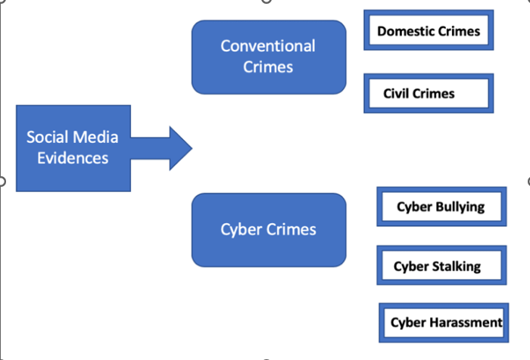
5.2 UML DIAGRAMS:
UML stands for Unified Modeling Language. UML is a standardized general-purpose modeling language in the field of object-oriented software engineering. The standard is managed, and was created by, the Object Management Group.
The goal is for UML to become a common language for creating models of object oriented computer software. In its current form UML is comprised of two major components: a Meta-model and a notation. In the future, some form of method or process may also be added to; or associated with, UML.
The Unified Modeling Language is a standard language for specifying, Visualization, Constructing and documenting the artifacts of software system, as well as for business modeling and other non-software systems.
The UML represents a collection of best engineering practices that have proven successful in the modeling of large and complex systems.
The UML is a very important part of developing objectsoriented software and the software development process. The UML uses mostly graphical notations to express the design of software projects.

GOALS:
The Primary goals in the design of the UML are as follows:
- Provide users a ready-to-use, expressive visual modeling Language so that they can develop and exchange meaningful models.
- Provide extendibility and specialization mechanisms to extend the core concepts.
- Be independent of particular programming languages and development process.
- Provide a formal basis for understanding the modeling language.
- Encourage the growth of OO tools market.
- Integrate best practices.

5.2.1 USE CASE DIAGRAM:
A use case diagram in the Unified Modeling Language (UML) is a type of behavioral diagram defined by and created from a Use-case analysis. Its purpose is to present a graphical overview of the functionality provided by a system in terms of actors, their goals (represented as use cases), and any dependencies between those use cases. The main purpose of a use case diagram is to show what system functions are performed for which actor. Roles of the actors in the system can bedepicted.
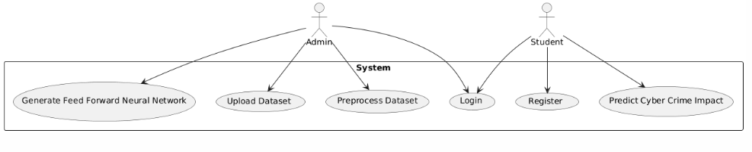

5.2.2 CLASS DIAGRAM:
In software engineering, a class diagram in the Unified Modeling Language (UML) is a type of static structure diagram that describes the structure of a system by showing the system's classes, their attributes, operations (or methods), and the relationships among the classes. It explains which class contains information.
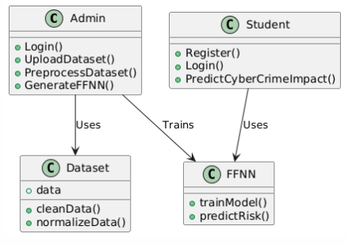

5.2.3 SEQUENCE DIAGRAM:
A sequence diagram in Unified Modeling Language (UML) is a kind of interaction diagram that shows how processes operate with one another and in what order. It is a construct of a Message Sequence Chart. Sequence diagrams are sometimes called event diagrams, event scenarios, and timing diagrams.
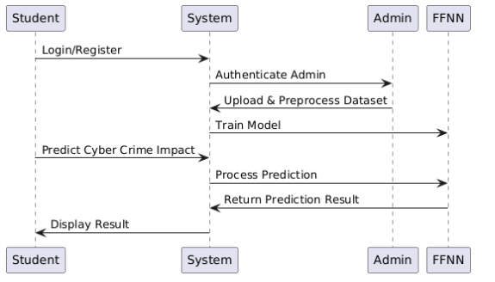

5.2.4 ACTIVITY DIAGRAM:
Activity diagrams are graphical representations of workflows of stepwise activities and actions with support for choice, iteration and concurrency. In the Unified Modeling Language, activity diagrams can be used to describe the business and operational step-by-step workflows of components in a system. An activity diagram shows the overall flow of control.

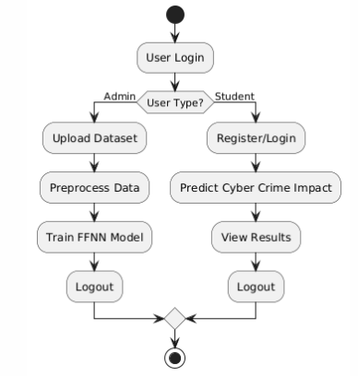

5.3 DATA FLOW DIAGRAM:

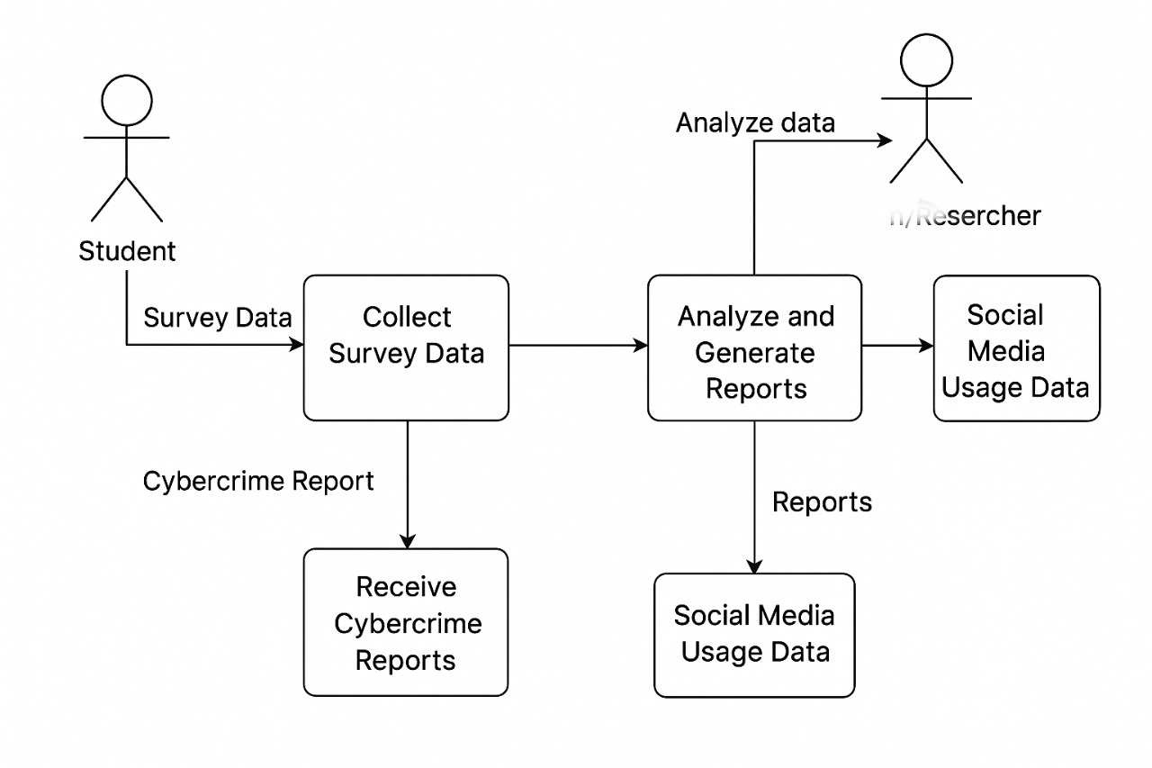

5.4 ER DIAGRAMS
An entity relationship diagram (er diagram) is a visual representation of how different entities (like people, objects, or concepts) relate to each other within a system, particularly in database design

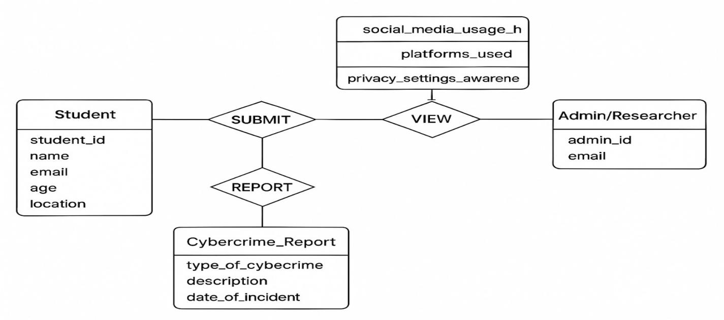

CHAPTER 6
SOURCE CODE

from django.shortcuts import render
import pandas as pd
from sklearn.model_selection import train_test_split
import joblib
import numpy as np
from sklearn.model_selection import train_test_split
from sklearn.preprocessing import LabelEncoder, StandardScaler, OneHotEncoder
import tensorflow as tf
from tensorflow.keras.models import Sequential
from tensorflow.keras.layers import Dense, Dropout
# Create your views here.
def index(request):
return render(request,'index.html')
def AdminAction(request):
uname=request.POST['username']
passw=request.POST['password']
if uname == 'Admin' and passw == 'Admin':
return render(request,'AdminApp/AdminHome.html')
else:context={'msg':'Admin Login Failed..!!'}
return render(request,'AdminApp/index.html',context)
def AdminHome(request):
return render(request,'AdminApp/AdminHome.html')
global data
def Upload(request):
# global data
#data=pd.read_csv("Dataset/sobar-72.csv", encoding='unicode_escape')
# context={'data':data,'msg':'Dataset Loaded Successfully..!!'}
return render(request,'AdminApp/Upload.html')
global df
def UploadAction(request):
global df
if request.method == 'POST':
file = request.FILES['dataset']
df = pd.read_csv(file)
columns = df.columns.tolist()
rows = df.head(10).values.tolist()
context = {'columns': columns, 'rows': rows}
return render(request, 'AdminApp/ViewDataset.html', context)
global X, X_train, X_test, y_train, y_test,incident_types_encoded
def preprocess(request):
global df,X, X_train, X_test, y_train, y_test,incident_types_encoded
# Mapping categorical variables using .map()
df["Gender"] = df["Gender"].map({"Male": 0, "Female": 1, "Other": 2})
df["Primary_Usage"] = df["Primary_Usage"].map({"Academic": 0, "Entertainment": 1, "Mixed": 2,"Social":3})
df["Has_Experienced_Cybercrime"] = df["Has_Experienced_Cybercrime"].map({"No": 0, "Yes": 1})
df["Two_Factor_Enabled"] = df["Two_Factor_Enabled"].map({"No": 0, "Yes": 1})
# One-hot encode target variable (Incident_Types)
incident_encoder = OneHotEncoder(sparse=False)
incident_types_encoded = incident_encoder.fit_transform(df[["Incident_Types"]])
# Drop non-numeric columns
df.drop(["Student_ID","State","Incident_Types", "Incident_Types_Description"], axis=1, inplace=True)
# Normalize numerical columns
scaler = StandardScaler()
X = scaler.fit_transform(df)
# Train-test split
X_train, X_test, y_train, y_test = train_test_split(X, incident_types_encoded, test_size=0.2, random_state=42)
context={'data':str(len(df)),'train':str(len(X_train)), 'test':str(len(y_test))}
return render(request, "AdminApp/Preprocess.html", context)
global adaacc,ada_model
def runANN(request):
global X, y, X_train, X_test, y_train, y_test
# Build neural network model
model = Sequential([
Dense(64, activation='relu', input_shape=(X_train.shape[1],)),
Dropout(0.2),
Dense(32, activation='relu'),
Dropout(0.2),
Dense(incident_types_encoded.shape[1], activation='softmax') # Multi-class output])
# Compile model
model.compile(optimizer='adam', loss='categorical_crossentropy', metrics=['accuracy'])
# Train model
history=model.fit(X_train, y_train, epochs=20, batch_size=32, validation_data=(X_test, y_test))
# Save model in 'Model' folder
model.save("Model/FFNeural_Network.h5")
train_acc = history.history['acc'][-1]
print(f"Model Accuracy: {train_acc * 100:.2f}%")
context={'data':'FeedForward Neural Network Model Generated Successfully..!!', 'acc': f"Model Accuracy: {train_acc * 100:.2f}%"}
return render(request, "AdminApp/Algorithms.html", context)

CHAPTER 7
SYSTEM ENVIRONMENT

7.1 SOFTWARE ENVIRONMENT
7.1.2 PYTHON
Python is a high-level, interpreted scripting language developed in the late 1980s by Guido van Rossum at the National Research Institute for Mathematics and Computer Science in the Netherlands. The initial version was published at the alt. Sources newsgroup in 1991, and version 1.0 was released in 1994.
Python 2.0 was released in 2000, and the 2.x versions were the prevalent releases until December 2008. At that time, the development team made the decision to release version 3.0, which contained a few relatively small but significant changes that were not backward compatible with the 2.x versions. Python 2 and 3 are very similar, and some features of Python 3 have been back ported to Python 2. But in general, they remain not quite compatible.
Both Python 2 and 3 have continued to be maintained and developed, with periodic release updates for both. As of this writing, the most recent versions available are 2.7.15 and 3.6.5. However, an official End of Life date of January 1, 2020 has been established for Python 2, after which time it will no longer be maintained. If you are a newcomer to Python, it is recommended that you focus on Python 3, as this tutorial will do.
Python is still maintained by a core development team at the Institute, and Guido is still in charge, having been given the title of BDFL (Benevolent Dictator For Life) by the Python community. The name Python, by the way, derives not from the snake, but from the British comedy troupe Monty Python’s Flying Circus, of which Guido was, and presumably still is, a fan. It is common to find references to Monty Python sketches and movies scattered throughout the Python documentation.

WHY CHOOSE PYTHON
If you’re going to write programs, there are literally dozens of commonly used languages to choose from. Why choose Python? Here are some of the features that make Python an appealing choice.
Python is Popular
Python has been growing in popularity over the last few years. The 2018 Stack Overflow Developer Survey ranked Python as the 7th most popular and the number one most wanted technology of the year. World-class software development countries around the globe use Python every single day.
According to research by Dice Python is also one of the hottest skills to have and the most popular programming language in the world based on the Popularity of Programming Language Index.
Due to the popularity and widespread use of Python as a programming language, Python developers are sought after and paid well. If you’d like to dig deeper into Python salary statistics and job opportunities, you can do so here.
Python is interpreted
Many languages are compiled, meaning the source code you create needs to be translated into machine code, the language of your computer’s processor, before it can be run. Programs written in an interpreted language are passed straight to an interpreter that runs them directly.
This makes for a quicker development cycle because you just type in your code and run it, without the intermediate compilation step.
One potential downside to interpreted languages is execution speed. Programs that are compiled into the native language of the computer processor tend to run more quickly than interpreted programs. For some applications that are particularly computationally intensive, like graphics processing or intense number crunching, this can be limiting.
In practice, however, for most programs, the difference in execution speed is measured in milliseconds, or seconds at most, and not appreciably noticeable to a human user. The expediency of coding in an interpreted language is typically worth it for most applications.
Python is Free
The Python interpreter is developed under an OSI-approved open-source license, making it free to install, use, and distribute, even for commercial purposes.
A version of the interpreter is available for virtually any platform there is, including all flavors of Unix, Windows, macOS, smart phones and tablets, and probably anything else you ever heard of. A version even exists for the half dozen people remaining who use OS/2.
Python is Portable
Because Python code is interpreted and not compiled into native machine instructions, code written for one platform will work on any other platform that has the Python interpreter installed. (This is true of any interpreted language, not just Python.)
Python is Simple
As programming languages go, Python is relatively uncluttered, and the developers have deliberately kept it that way.
A rough estimate of the complexity of a language can be gleaned from the number of keywords or reserved words in the language. These are words that are reserved for special meaning by the compiler or interpreter because they designate specific built-in functionality of the language.
Python 3 has 33 keywords, and Python 2 has 31. By contrast, C++ has 62, Java has 53, and Visual Basic has more than 120, though these latter examples probably vary somewhat by implementation or dialect.
Python code has a simple and clean structure that is easy to learn and easy to read. In fact, as you will see, the language definition enforces code structure that is easy to read.
But It’s Not That Simple For all its syntactical simplicity, Python supports most constructs that would be expected in a very high-level language, including complex dynamic data types, structured and functional programming, and object-oriented programming.
Additionally, a very extensive library of classes and functions is available that provides capability well beyond what is built into the language, such as database manipulation or GUI programming.
Python accomplishes what many programming languages don’t: the language itself is simply designed, but it is very versatile in terms of what you can accomplish with it.
Conclusion
This section gave an overview of the Python programming language, including:
• A brief history of the development of Python
• Some reasons why you might select Python as your language of choice
Python is a great option, whether you are a beginning programmer looking to learn the basics, an experienced programmer designing a large application, or anywhere in between. The basics of Python are easily grasped, and yet its capabilities are vast. Proceed to the next section to learn how to acquire and install Python on your computer.
Python is an open source programming language that was made to be easy-to-read and powerful. A Dutch programmer named Guido van Rossum made Python in 1991. He named it after the television show Monty Python's Flying Circus. Many Python examples and tutorials include jokes from the show.
Python is an interpreted language. Interpreted languages do not need to be compiled to run. A program called an interpreter runs Python code on almost any kind of computer. This means that a programmer can change the code and quickly see the results. This also means Python is slower than a compiled language like C, because it is not running machine code directly.
Python is a good programming language for beginners. It is a high-level language, which means a programmer can focus on what to do instead of how to do it. Writing programs in Python takes less time than in some other languages.
Python drew inspiration from other programming languages like C, C++, Java, Perl, and Lisp.
Python has a very easy-to-read syntax. Some of Python's syntax comes from C, because that is the language that Python was written in. But Python uses whitespace to delimit code: spaces or tabs are used to organize code into groups. This is different from C. In C, there is a semicolon at the end of each line and curly braces ({}) are used to group code. Using whitespace to delimit code makes Python a very easy-to-read language.
Python use [change / change source]
Python is used by hundreds of thousands of programmers and is used in many
places. Sometimes only Python code is used for a program, but most of the time it is used to do simple jobs while another programming language is used to do more complicated tasks.
Its standard library is made up of many functions that come with Python when it is installed. On the Internet there are many other libraries available that make it possible for the Python language to do more things. These libraries make it a powerful language; it can do many different things.
Some things that Python is often used for are:
• Web development
• Scientific programming
• Desktop GUIs
• Network programming
• Game programming
7.2 Machine Learning
Machine Learning (ML) is a subset of artificial intelligence (AI) that focuses on building systems that can learn from data, identify patterns, and make decisions with minimal human intervention. The fundamental idea behind machine learning is that systems can automatically learn from past experiences (i.e., data) and improve their performance over time without being explicitly programmed for every task.
At its core, machine learning enables computers to identify relationships between data points and make predictions or decisions based on that data. It plays a critical role in many modern applications, such as recommendation systems, speech recognition, computer vision, fraud detection, autonomous vehicles, and natural language processing.

Key Concepts in Machine Learning
1. Data: Machine learning relies heavily on data. Data can come in many forms: numerical, categorical, text, images, etc. The quality and quantity of data often determine the success of a machine learning model.
2. Model: A model is a mathematical representation of the relationships in the data. In ML, algorithms are used to build models by learning from the data. These models make predictions or decisions based on input data.
3. Training: This is the process of teaching the machine learning model. During training, the model is provided with data (training data) and adjusts its parameters to minimize errors in its predictions or decisions.
4. Testing: After training, the model is evaluated on new, unseen data (testing data) to assess its generalization ability—i.e., how well it can make predictions on data it has not been trained on.
5. Features: Features are individual measurable properties or characteristics of the data that are used by the machine learning algorithm to make predictions. In an image, for instance, features could be pixels or specific objects in the image.
6. Labels: Labels are the outputs or targets that the model is trying to predict (e.g., identifying whether an image contains a dog or a cat).
7. Loss Function: A loss function quantifies how far the model’s predictions are from the actual results. The goal during training is to minimize the loss function, which is done through optimization techniques.
8. Optimization: This is the process of adjusting the model’s parameters (weights) to minimize the loss function and improve the model’s accuracy.
7.2.1 Types of Machine Learning
Machine learning can generally be classified into three main categories:
1. Supervised Learning
Supervised learning is a type of machine learning where the model is trained using labeled data. In this approach, the algorithm learns a mapping from inputs to the desired output based on the provided labels.
Training Process: The algorithm is provided with input-output pairs (labeled data), and it learns a function to predict the output for unseen inputs.
Examples:
o Classification: Categorizing emails as spam or not spam.
o Regression: Predicting house prices based on features like size, location, etc.
Common Algorithms:
• Linear Regression
• Logistic Regression
• Decision Trees
• Random Forests
• Support Vector Machines (SVM)
• Neural Networks
2. Unsupervised Learning
In unsupervised learning, the model is trained using unlabeled data. The goal is to identify hidden patterns or structures in the data without predefined labels.
• Training Process: The algorithm tries to learn the underlying structure or distribution of the data.
Examples:
Clustering: Grouping customers by purchasing behavior.
Dimensionality Reduction: Reducing the number of features while retaining the important information.
Common Algorithms:
• K-means Clustering
• Hierarchical Clustering
• Principal Component Analysis (PCA)
• Autoencoders
3. Reinforcement Learning (RL)
Reinforcement learning is based on an agent interacting with an environment to learn how to achieve a goal. The agent takes actions and receives feedback in the form of rewards or penalties. The goal is to maximize the cumulative reward over time.
Training Process: The agent learns a policy that dictates the best action to take in a given state in order to maximize the total long-term reward.
Examples:
Game-playing AI (e.g., AlphaGo).
Robotics: Learning to navigate or perform tasks.
Common Algorithms:
• Q-Learning
• Deep Q Networks (DQN)
• Policy Gradient Methods
• Actor-Critic Methods

Key Challenges in Machine Learning
1.Overfitting and Underfitting:
Overfitting: When the model learns the details and noise in the training data to the extent that it negatively impacts its performance on new data.
Underfitting: When the model is too simple to capture the underlying pattern in the data, resulting in poor performance on both the training data and the testing data.
2. Bias-Variance Tradeoff:
The balance between a model’s ability to generalize to unseen data and its ability to capture complex patterns in the data. A high bias can lead to underfitting, while a high variance can lead to overfitting.
3. Data Quality and Quantity:
Having high-quality data is crucial for building effective machine learning models. Poor or incomplete data can lead to inaccurate predictions.
Larger datasets generally improve model accuracy, but acquiring high-quality data can be time-consuming and expensive.
4. Interpretability:
Some machine learning models, especially deep learning models, are often considered "black boxes," making it difficult to understand how they arrive at a particular decision. Interpretability is important, especially in domains like healthcare and finance, where understanding the reasoning behind predictions is critical.
5. Computational Resources:
Many machine learning algorithms, especially deep learning models, require significant computational power. This can be a challenge in terms of both hardware and time.
Applications of Machine Learning
Machine learning has a wide range of applications across industries. Some notable areas include:
- Healthcare:
- Disease diagnosis (e.g., using medical images to detect tumors).
- Personalized treatment recommendations.
- Drug discovery and genomics.
Finance:
- Fraud detection and risk assessment.
- Algorithmic trading.
- Credit scoring and lending.
- E-commerce and Marketing:
- Product recommendations (e.g., Amazon, Netflix).
- Customer segmentation and targeting.
- Dynamic pricing.
4. Autonomous Vehicles:
Self-driving cars rely on machine learning for perception (e.g., object detection, lane detection) and decision-making (e.g., navigation, obstacle avoidance).
5. Natural Language Processing (NLP):
1. Machine translation (e.g., Google Translate).
2. Sentiment analysis.
3. Speech recognition and virtual assistants (e.g., Siri, Alexa).
6. Manufacturing:
1. Predictive maintenance (identifying when machines need maintenance before they fail).
2. Quality control using image recognition.

7.2.2 Future of Machine Learning
Machine learning is a rapidly evolving field with the potential to revolutionize many industries. Some key areas of future development include:
1.Deep Learning Advancements: The continuous improvement of deep learning techniques, especially in areas like neural architecture search and self-supervised learning, will drive progress in computer vision, NLP, and more.
2. Edge AI and Federated Learning: Machine learning models running on edge devices (e.g., smartphones, IoT devices) will allow for faster, real-time processing with reduced reliance on cloud computing. Federated learning allows models to be trained on decentralized data without needing to move data to a central server, ensuring privacy and reducing latency.
3. Ethical AI: As machine learning becomes more pervasive, addressing ethical concerns (such as fairness, accountability, and transparency) will be crucial to prevent biases in models and ensure the responsible use of AI.
4. Explainable AI (XAI): Developing techniques to make machine learning models more interpretable and understandable will be important for applications in healthcare, finance, and law, where decisions need to be explainable.
5. AI and Automation: Machine learning will continue to drive automation in various sectors, from manufacturing to customer service, leading to increased productivity and efficiency.
7.3 Django
Django is an open-source, high-level Python web framework that enables rapid development of secure and maintainable websites and web applications. It follows the Model-View-Template (MVT) architectural pattern, which is similar to the widely-known Model-View-Controller (MVC) pattern but with some subtle differences in naming and implementation. Django's design philosophy is based on the idea of "Don't repeat yourself" (DRY) and aims to reduce the complexity of web development by providing reusable components and an organized structure.
Django was created by Adrian Holovaty and Simon Willison in 2003, and it was publicly released in 2005. It has grown to become one of the most popular web frameworks in the Python ecosystem due to its robustness, security features, and scalability.

Key Features of Django
- Rapid Development:
- Django encourages rapid development by offering a lot of built-in features and tools out-of-the-box. This allows developers to focus more on building application-specific functionality rather than reinventing the wheel.
- Security:
Django includes several built-in security features to protect web applications from common vulnerabilities:
SQL Injection: Django's ORM (Object-Relational Mapping) automatically escapes SQL queries, reducing the risk of SQL injection attacks.
Cross-Site Scripting (XSS): Django templates escape data by default to prevent injection of malicious scripts into web pages.
Cross-Site Request Forgery (CSRF): Django includes protection mechanisms for preventing CSRF attacks by requiring tokens for form submissions.
Clickjacking Protection: Django has built-in middleware to prevent clickjacking attacks.
Password Management: Django offers secure password storage using salted hashes and automatic password hash upgrades.
3. Scalability:
Django supports scalability in both vertical (handling more traffic on a single server) and horizontal (distributing load across multiple servers) ways. It can scale with the demands of high-traffic websites, making it suitable for both small-scale applications and large-scale enterprise applications.
4. Reusable Components:
Django encourages the use of reusable components (called "apps") that can be plugged into multiple projects. Each app typically encapsulates a specific functionality (e.g., user authentication, blog, comments) and can be reused across projects.
5. Admin Interface:
Django includes a powerful and customizable admin panel that allows developers and administrators to manage the database content. The admin interface is automatically generated based on the models defined in Django and provides a user-friendly interface to manage data.
6. Object-Relational Mapping (ORM):
Django comes with a built-in ORM that abstracts the interaction between Python code and relational databases like MySQL, PostgreSQL, SQLite, and others. Developers can define database models as Python classes and interact with the database using Python code rather than raw SQL queries.
7. Routing and URL Mapping:
Django uses an easy-to-understand URL routing system to map URLs to specific views. URL patterns are defined in a central configuration file, and each URL can be mapped to a corresponding Python function or view.
8. Template Engine:
Django’s templating engine allows developers to create dynamic HTML pages by embedding logic in templates. It also supports inheritance, allowing for reusable components like headers, footers, and navigation menus.
9. Internationalization and Localization:
Django includes built-in tools to support multilingual websites, making it easy to translate content and serve websites in different languages based on user preferences or location.
10. Testing Framework:
Django includes a test framework that enables developers to write unit tests for their applications. It includes tools for simulating HTTP requests, testing views, and checking the correctness of business logic, all of which help maintain the integrity of the web application.

Django Architecture and Components
Django follows the Model-View-Template (MVT) pattern:
- Model (M):
The Model is responsible for defining the data structure of the application, including database schema, relationships, and data validation. In Django, models are Python classes that represent database tables. The Django ORM automatically handles CRUD (Create, Read, Update, Delete) operations on the database.
2. View (V):
The View is responsible for handling HTTP requests and returning responses. It receives input from the user, interacts with the model, and returns the output (typically rendered HTML). Views in Django are written as Python functions or class-based views (CBVs) that receive HTTP requests, process them, and return an HTTP response.
3. Template (T):
The Template is responsible for rendering the dynamic content of the web page (HTML). It contains HTML with placeholders for dynamic data, which Django fills in when rendering the page. The template engine provides logic like loops, conditionals, and variable substitution to create dynamic web pages.

How Django Works:
1. Request and Routing:
A user sends an HTTP request to the Django web server (e.g., by typing a URL in the browser).
The request is routed through Django's URL dispatcher, which maps the URL to a specific view function.
2. Processing the Request:
The view function processes the request, retrieves any necessary data from the database (using models), and prepares a context to send to the template for rendering.
3. Template Rendering:
The template engine takes the context data and renders it into an HTML response. This is where dynamic content (e.g., user-specific data, posts, products) is inserted into predefined templates.
4. Sending the Response:
The rendered HTML response is sent back to the user's browser.

7.3.1 Advantages of Django:
1. Rapid Development: Django's comprehensive set of built-in tools (like authentication, URL routing, and an admin interface) allows developers to quickly create applications without needing to build everything from scratch.
2. Security: Django follows security best practices and includes features to protect against common security threats, which helps developers focus on building features without worrying about vulnerabilities.
3. Scalability: Django is designed to handle both small and large applications, making it suitable for anything from small websites to high-traffic platforms like Instagram, Pinterest, and YouTube.
4. Community and Ecosystem: Django has a large and active community, which means plenty of third-party libraries, plugins, and resources are available. The community also ensures that the framework is continually evolving.
5. Cross-platform: Django can run on any platform that supports Python, including Windows, macOS, and Linux, making it easy to develop and deploy applications in a variety of environments.
6. Well-Documented: Django has excellent documentation, including tutorials for beginners, which makes it easy for developers to get started.
7. Versatility: Django is suitable for a variety of use cases, such as content management systems (CMS), e-commerce platforms, social networks, scientific computing platforms, and more.

7.3.2 Disadvantages of Django:
1. Monolithic Approach: Django’s "batteries-included" philosophy means that it can be heavy for small applications or microservices where only a small portion of Django’s capabilities are required. The full-stack nature may not be ideal for very lightweight applications.
2. Learning Curve: While Django simplifies many aspects of web development, beginners may find it challenging at first due to its complexity, especially when using advanced features such as class-based views or integrating external libraries.
3. Less Flexible than Some Frameworks: While Django's built-in features are a strength, they can sometimes be seen as restrictive. For instance, Django enforces a particular way of doing things, which can feel limiting if you want more freedom or are building very custom functionality.
4. Performance Overhead: Because Django includes many built-in features, there can be performance overhead for very simple applications. However, this is typically offset by the development speed.

7.3.3 Popular Use Cases of Django:
1. Content Management Systems (CMS): Django is widely used for building dynamic content-driven websites, such as blogs, news sites, and media portals.
2. E-commerce Websites: Django’s scalability and modularity make it a popular choice for creating online stores, product catalogs, and marketplaces.
3. Social Networks: Django's ability to handle complex relationships and high-traffic loads makes it an ideal framework for building social networking platforms.
4. APIs and RESTful Services: With the Django Rest Framework (DRF), Django is also commonly used for building APIs and serving data to web and mobile apps.
5. Scientific Computing: Django is used in the scientific community for building web-based applications for data visualization, analysis, and collaboration.

CHAPTER-8
TESTING

8.1 SYSTEM TESTING
The purpose of testing is to discover errors. Testing is the process of trying to discover every conceivable fault or weakness in a work product. It provides a way to check the functionality of components, subassemblies, assemblies and/or a finished product It is the process of exercising software with the intent of ensuring that the Software system meets its requirements and user expectations and does not fail in an unacceptable manner. There are various types of test. Each test type addresses a specific testing requirement.

8.2 TYPES OF TESTING

The following are the Testing Methodologies:
- Unit Testing.
- Integration Testing.
- White Box Testing.
- Black Box Testing.
- Acceptance Testing.

8.2.1 Unit Testing
Unit testing:
Unit testing involves the design of test cases that validate that the internal program logic is functioning properly, and that program inputs produce valid outputs. All decision branches and internal code flow should be validated. It is the testing of individual software units of the application .it is done after the completion of an individual unit before integration. This is a structural testing, that relies on knowledge of its construction and is invasive. Unit tests perform basic tests at component level and test a specific business process, application, and/or system configuration. Unit tests ensure that each unique path of a business process performs accurately to the documented specifications and contains clearly defined inputs and expected results.
Integration testing:
Integration tests are designed to test integrated software components to determine if they actually run as one program. Testing is event driven and is more concerned with the basic outcome of screens or fields. Integration tests demonstrate that although the components were individually satisfaction, as shown by successfully unit testing, the combination of components is correct and consistent. Integration testing is specifically aimed at exposing the problems that arise from the combination of components.
Functional test:
Functional tests provide systematic demonstrations that functions tested are available as specified by the business and technical requirements, system documentation, and user manuals.
Functional testing is centered on the following items:
Valid Input: identified classes of valid input must be accepted.
Invalid Input: identified classes of invalid input must be rejected.
Functions: identified functions must be exercised.
Output: identified classes of application outputs must be exercised.
Systems/Procedures: interfacing systems or procedures must be invoked.
Organization and preparation of functional tests is focused on requirements, key functions, or special test cases. In addition, systematic coverage pertaining to identify Business process flows; data fields, predefined processes, and successive processes must be considered for testing. Before functional testing is complete, additional tests are identified and the effective value of current tests is determined.
System Test:
System testing ensures that the entire integrated software system meets requirements. It tests a configuration to ensure known and predictable results. An example of system testing is the configuration oriented system integration test. System testing is based on process descriptions and flows, emphasizing pre-driven process links and integration points.
White Box Testing:
White Box Testing is a testing in which in which the software tester has knowledge of the inner workings, structure and language of the software, or at least its purpose. It is purpose. It is used to test areas that cannot be reached from a black box level.
Black Box Testing:
Black Box Testing is testing the software without any knowledge of the inner workings, structure or language of the module being tested. Black box tests, as most other kinds of tests, must be written from a definitive source document, such as specification or requirements document, such as specification or requirements document. It is a testing in which the software under test is treated, as a black box .you cannot “see” into it. The test provides inputs and responds to outputs without considering how the software works.
Unit Testing:
Unit testing is usually conducted as part of a combined code and unit test phase of the software lifecycle, although it is not uncommon for coding and unit testing to be conducted as two distinct phases.
Test strategy and approach:
Field testing will be performed manually and functional tests will be written in detail.
Test objectives:
• All field entries must work properly.
• Pages must be activated from the identified link.
• The entry screen, messages and responses must not be delayed.

Features to be tested
• Verify that the entries are of the correct format
• No duplicate entries should be allowed
• All links should take the user to the correct page. Integration Testing
Software integration testing is the incremental integration testing of two or more integrated software components on a single platform to produce failures caused by interface defects.
The task of the integration test is to check that components or software applications, e.g. components in a software system or – one step up – software applications at the company level – interact without error.
Test Results: All the test cases mentioned above passed successfully. No defects encountered.

Acceptance Testing
User Acceptance Testing is a critical phase of any project and requires significant participation by the end user. It also ensures that the system meets the functional requirements.
Test Results: All the test cases mentioned above passed successfully. No defects encountered.

CHAPTER 9
RESULTS

9.1 SCREENSHOTS
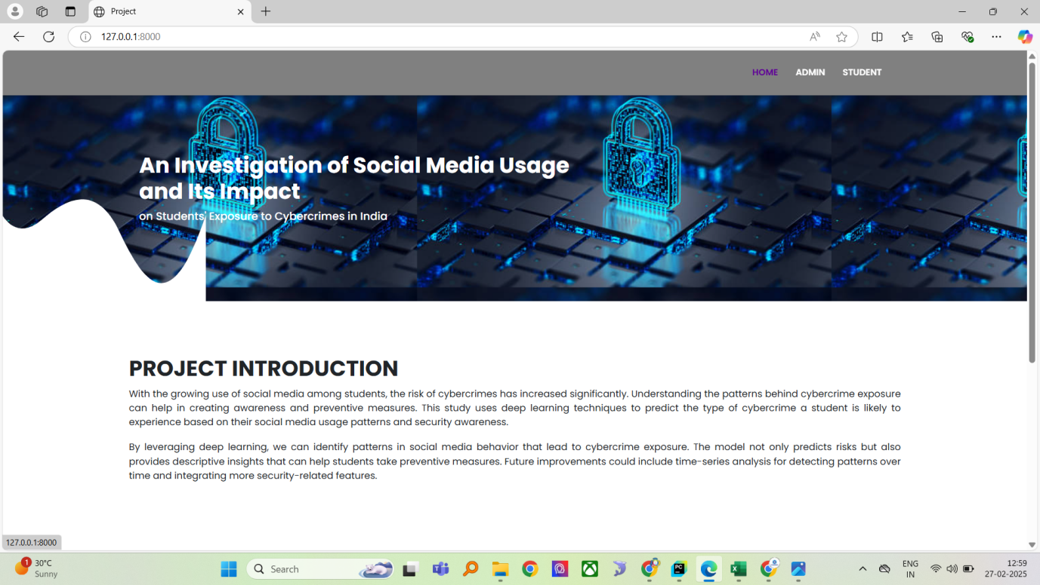
Fig 9.1.1
Admin login
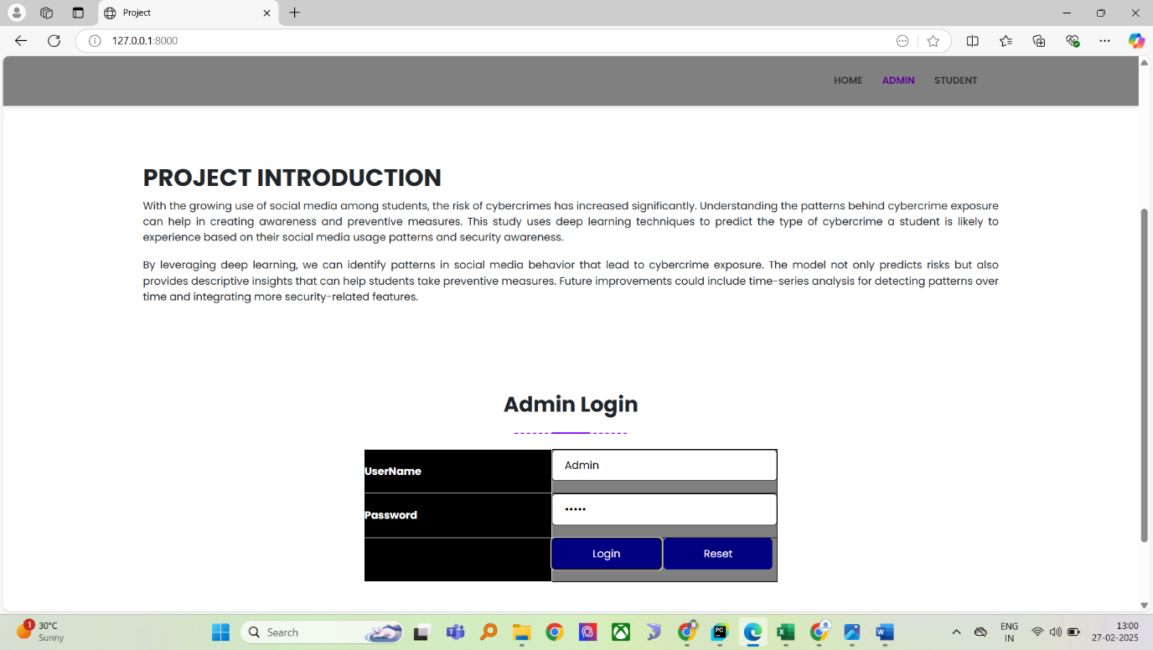
Fig 9.1.2

Admin home
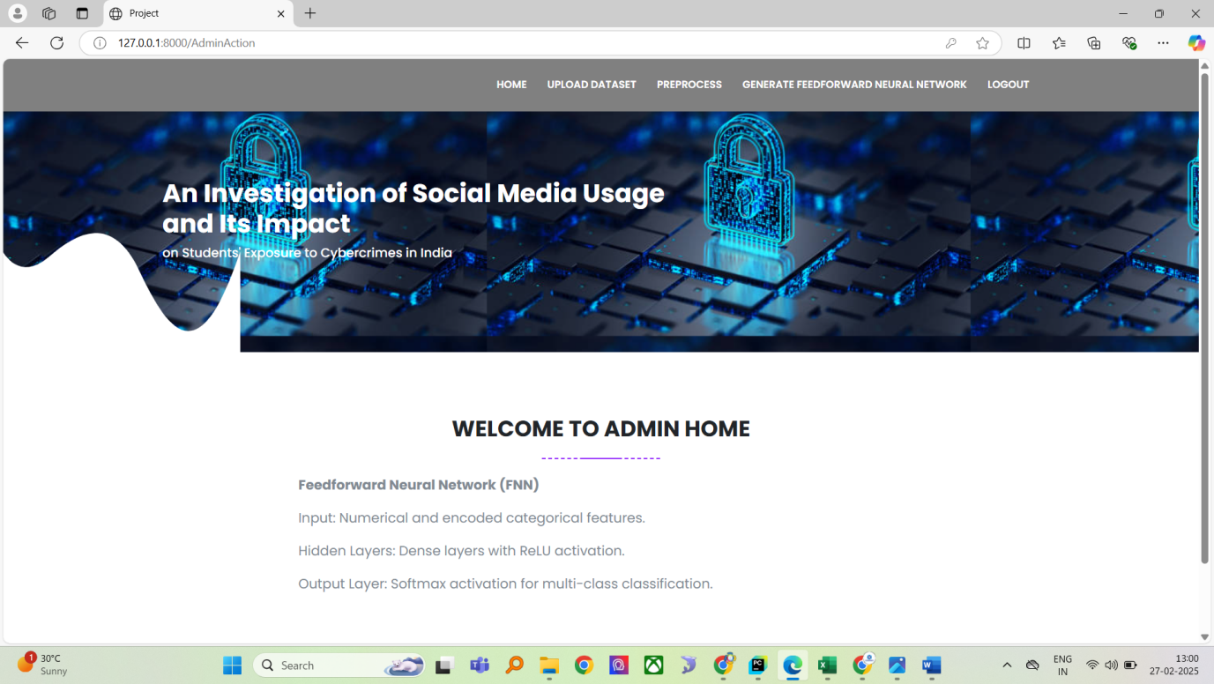
Fig 9.1.3
Upload dataset
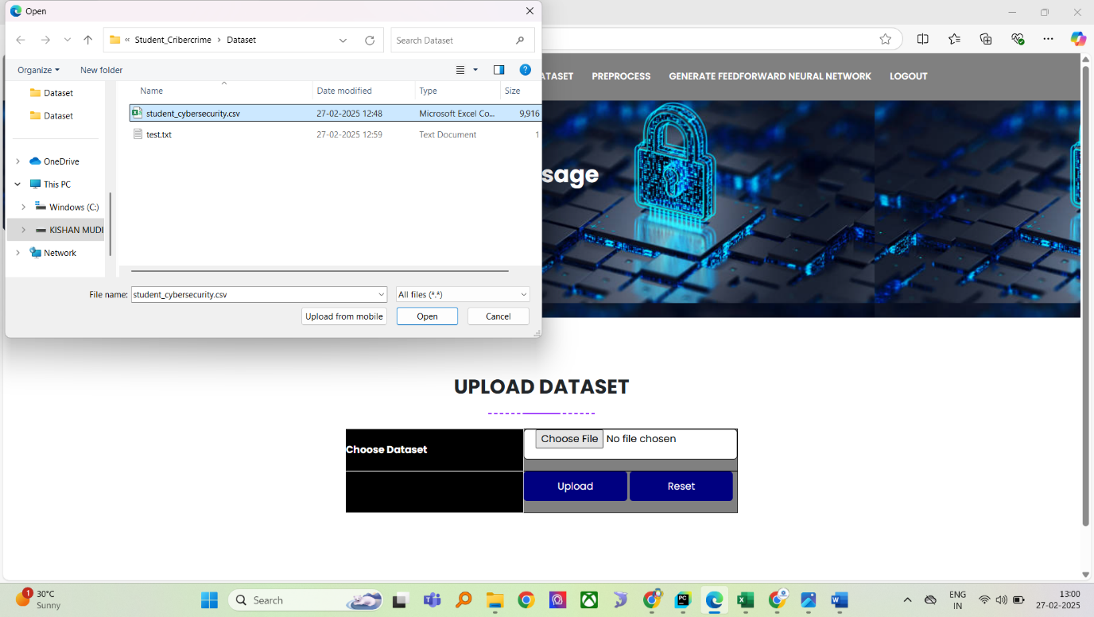
Fig 9.1.4

View dataset
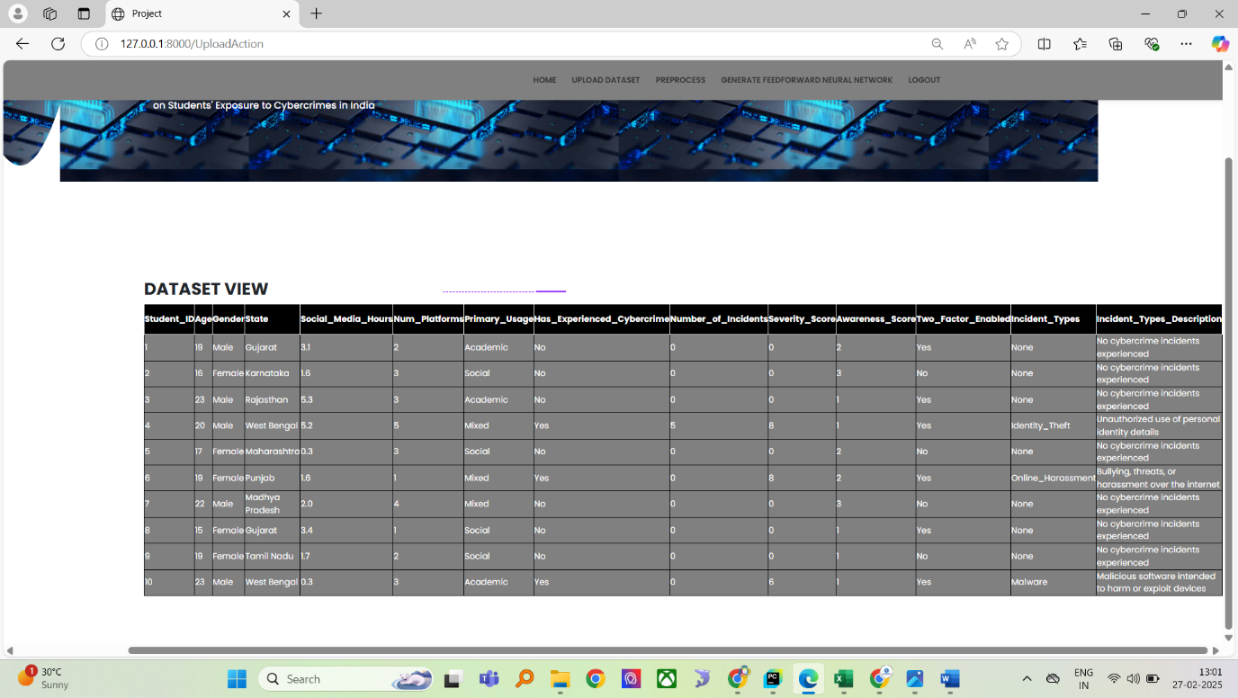
Fig 9.1.5
preprocess data

Fig 9.1.6

Training model
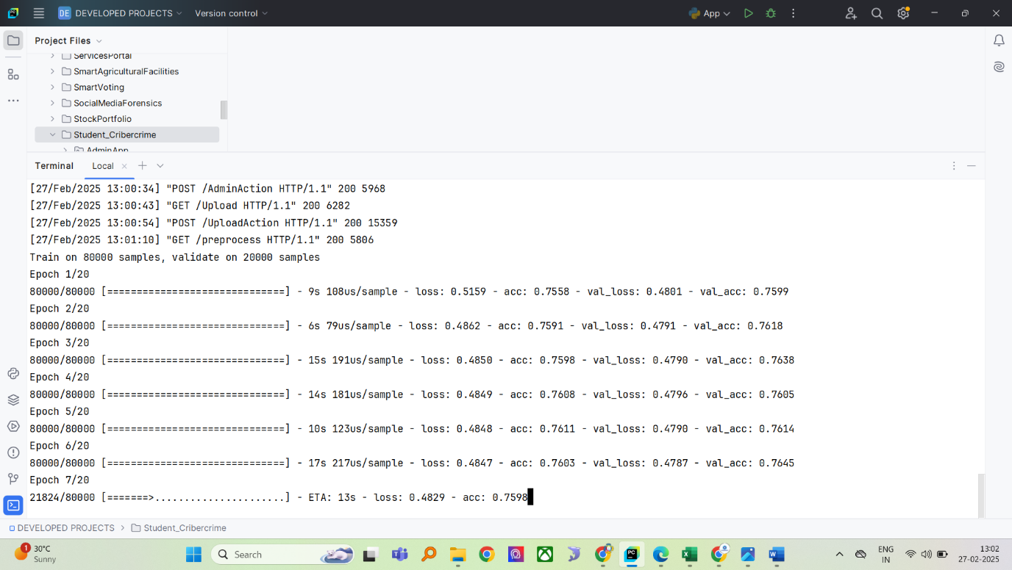
Fig 9.1.7
Model accuracy
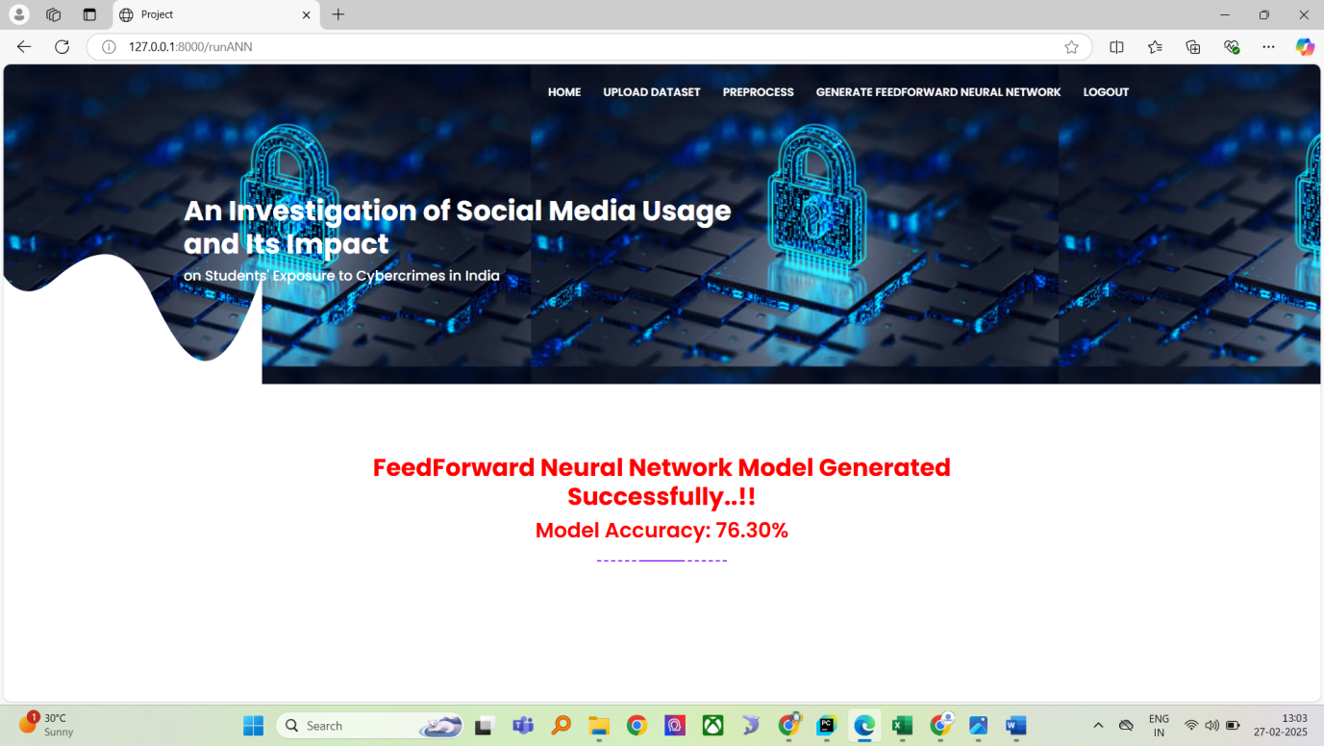
Fig 9.1.8

Student registration
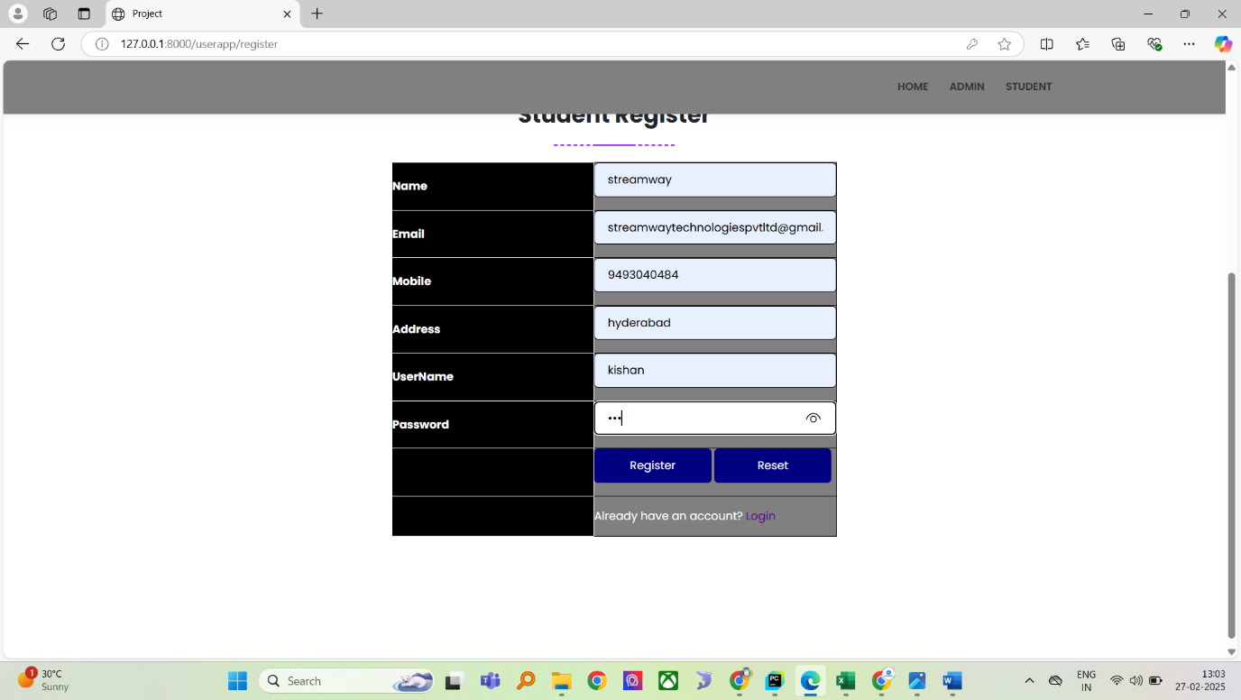
Fig 9.1.9
Student login
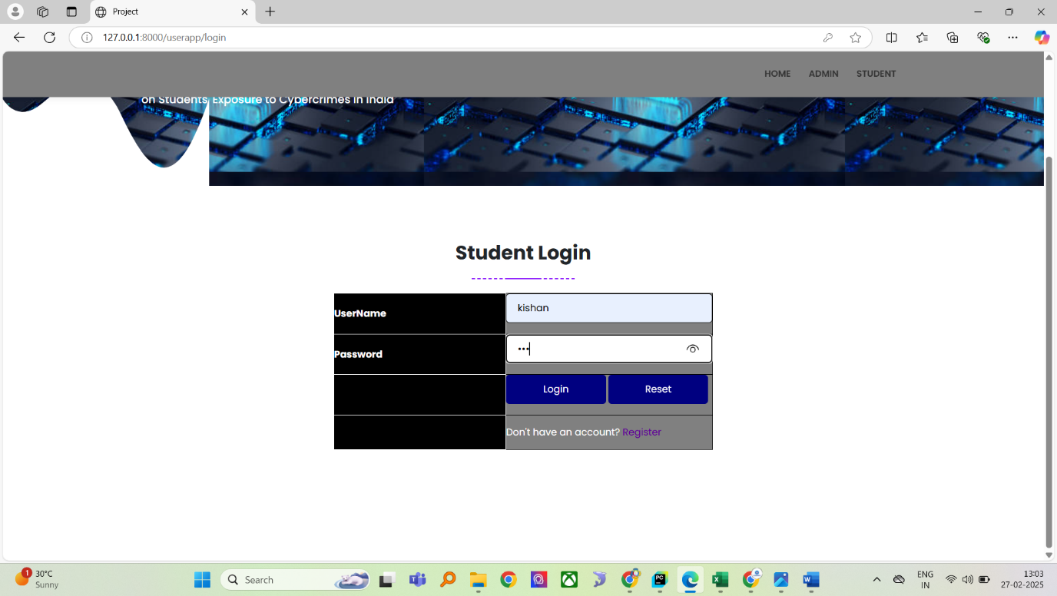
Fig 9.1.10

Student home

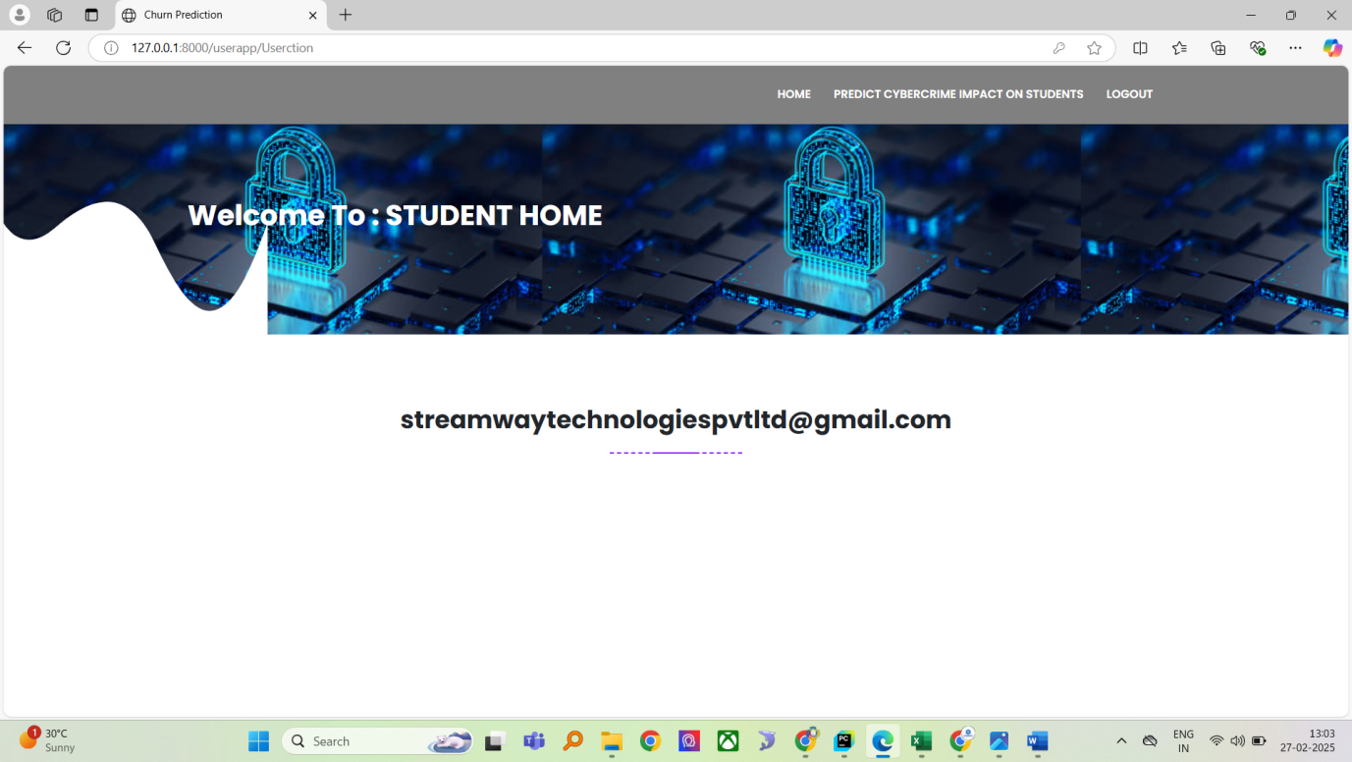
Fig 9.1.11
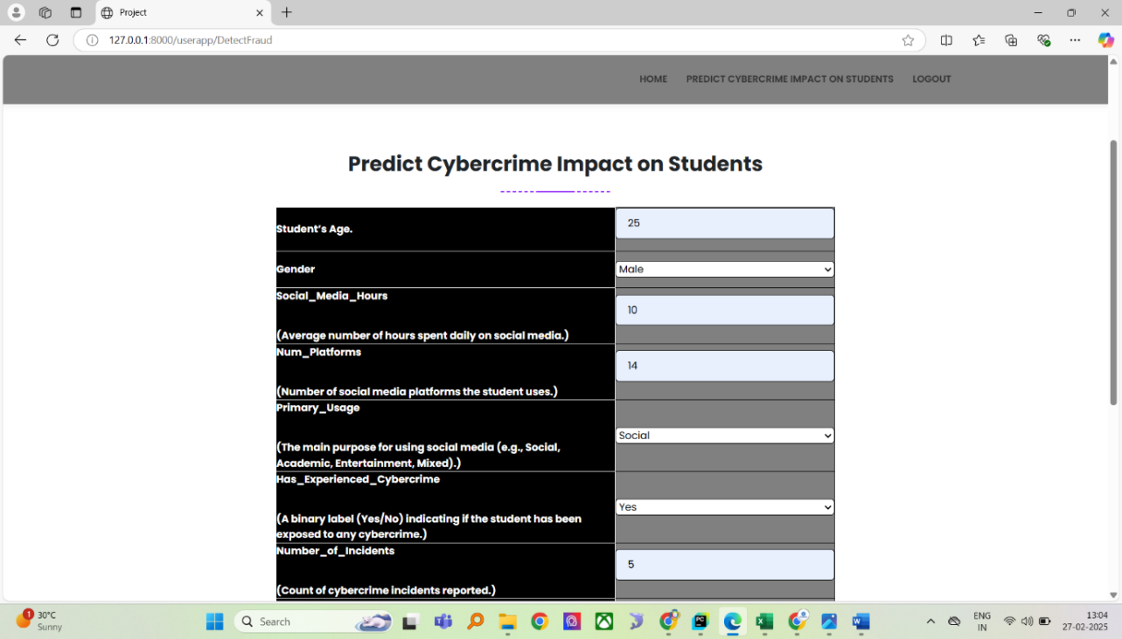
Fig 9.1.12
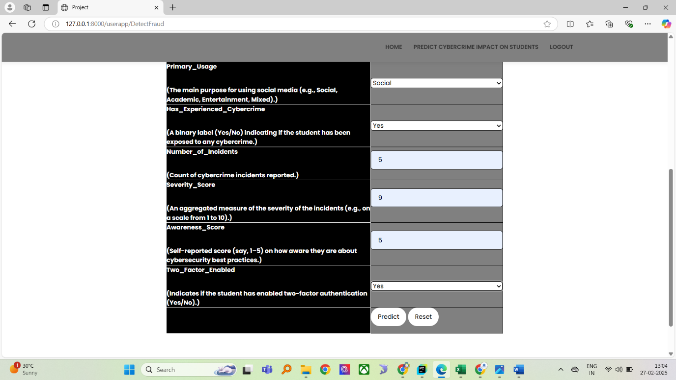
Fig 9.1.13
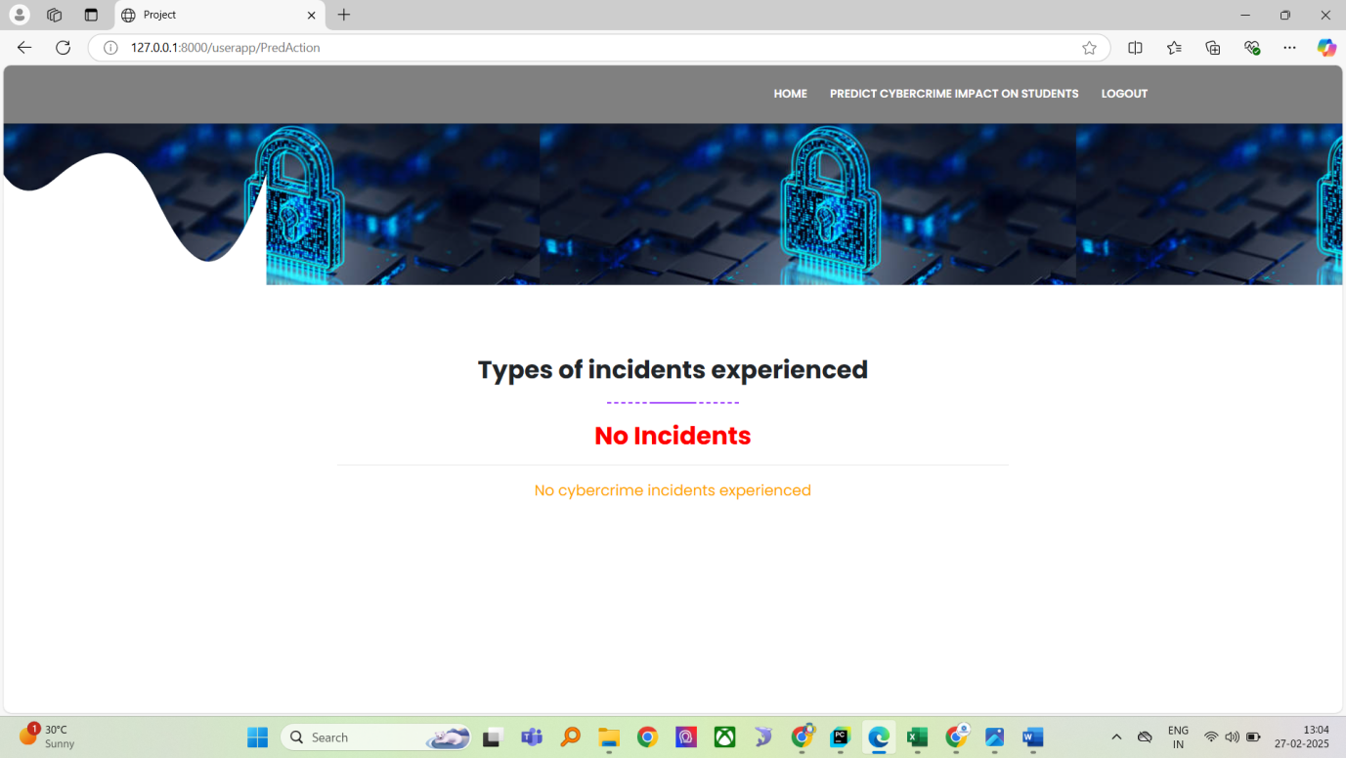
Fig 9.1.14
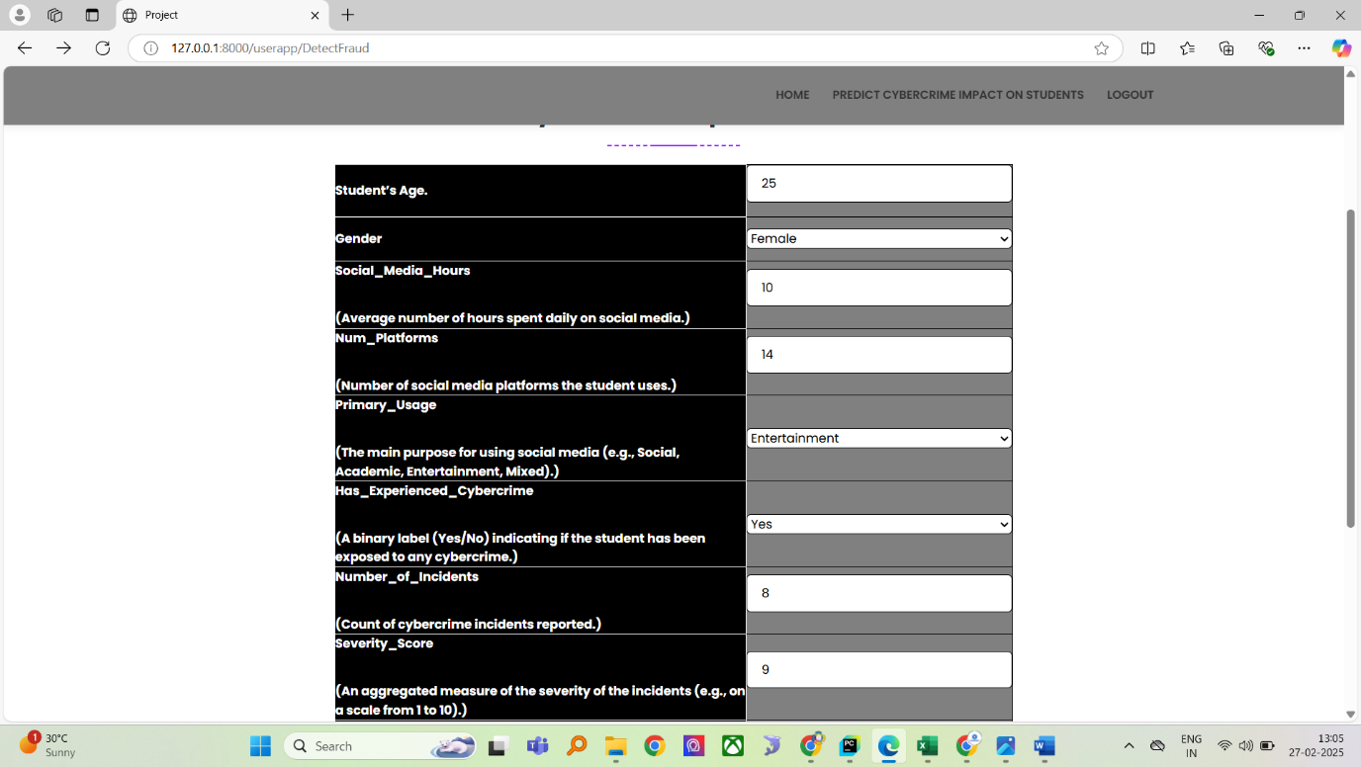
Fig 9.1.15
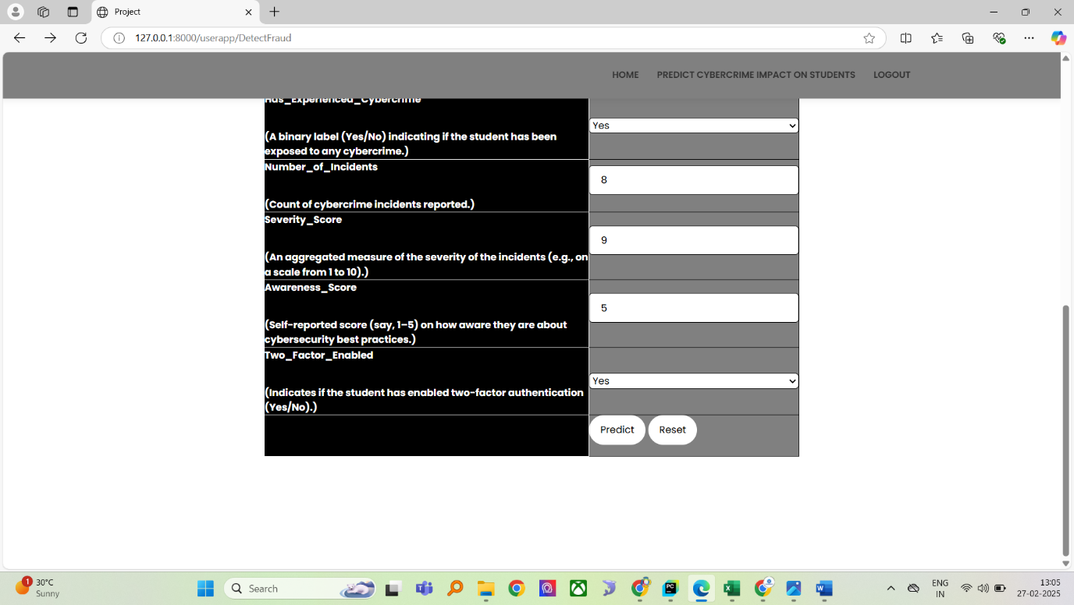
Fig 9.1.16
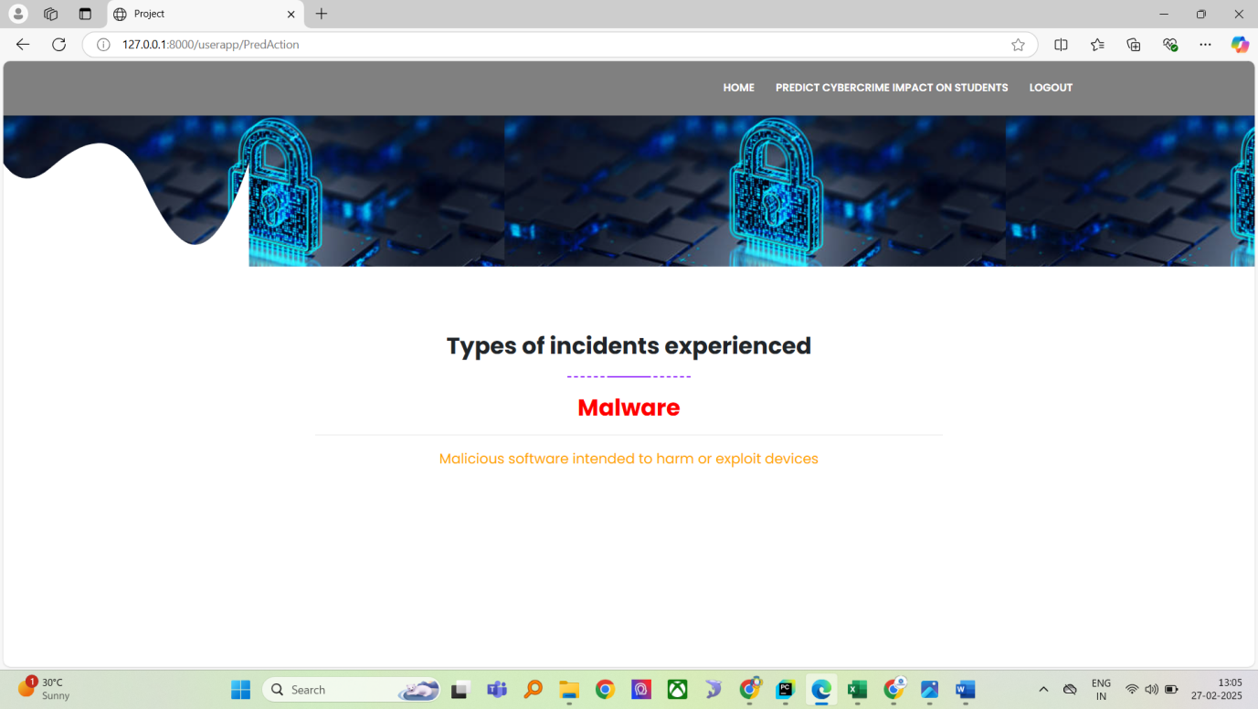
Fig 9.1.17

CHAPTER 10

CONCLUSION

10.1 CONCLUSION:
The increasing dependence of students on social media exposes them to various cyber threats, making it essential to develop predictive models for cybercrime risk assessment. This project proposes a Feed Forward Neural Network (FFNN)-based system to analyze and predict students' exposure to cyber threats based on their online activities.
The system consists of two main modules: Admin and Student. The Admin module handles data upload, preprocessing, and model training, while the Student module allows users to register, log in, and predict their risk of cybercrime exposure. By leveraging machine learning, the proposed system enhances the accuracy of cyber threat detection and provides personalized risk assessments.
The implementation of this system can help students become more aware of potential cyber threats and take necessary precautions. Additionally, educational institutions and policymakers can use the insights generated by the model to create awareness programs and improve cybersecurity measures. Future enhancements could include incorporating real-time data analysis, sentiment analysis, and advanced deep learning techniques to further improve predictive accuracy.

CHAPTER 11
FUTURE ENHANCEMENTS

11.1 FUTURE ENHANCEMENTS
The proposed system can be further enhanced by integrating advanced technologies and expanding its capabilities. Some key areas for future improvements include:
- Real-Time Cyber Threat Detection
  - Implementing real-time monitoring of social media activity to detect potential threats instantly.
  - Using natural language processing (NLP) to analyze messages, comments, and posts for cyber threats like phishing, cyberbullying, and fraud.
- Integration with AI-Driven Chatbots
  - Developing AI-powered chatbots that can alert users about suspicious activities and provide cybersecurity tips.
  - Enabling automated assistance for students to understand and mitigate cyber threats.
- Enhanced Machine Learning Models
  - Exploring advanced deep learning techniques such as Recurrent Neural Networks (RNN), Transformers, and LSTMs for better cyber threat prediction.
  - Implementing reinforcement learning to improve system accuracy based on user feedback.
- Cross-Platform Social Media Analysis
  - Expanding the system to analyze multiple social media platforms (Facebook, Instagram, Twitter, WhatsApp, etc.) for potential cyber threats.
  - Implementing API-based data extraction for dynamic and real-time analysis.
- User Behavior and Sentiment Analysis
  - Using sentiment analysis to detect negative emotions, cyberbullying, or suspicious activities in social media interactions.
  - Tracking behavioral patterns to identify potential victims or perpetrators of cybercrimes.
- Blockchain for Enhanced Security
  - Integrating blockchain technology for secure and tamper-proof data storage.
  - Ensuring decentralized security to prevent unauthorized modifications in datasets.
- Mobile App Development
  - Creating a mobile-friendly application to make cybercrime risk assessments more accessible to students.
  - Sending instant notifications and alerts for potential cyber threats.
- Collaboration with Educational Institutions
  - Partnering with schools and universities to promote cybersecurity awareness programs.
  - Providing customized reports to help educators and parents understand students’ online risks.
- Multi-Language Support
  - Implementing language translation features to expand the system’s usability for students across different regions in India.
- Cybercrime Reporting Mechanism
  - Introducing a feature that allows students to report cyber threats directly to law enforcement or cybersecurity agencies for faster action.

CHAPTER 12

REFERENCES

12.1 REFERENCES
- Kumar, R., & Sharma, S. (2023). "Impact of Social Media on Cybersecurity Awareness Among Students." Journal of Cyber Intelligence and Security, 10(2), 45-60.
- Patel, M., & Singh, A. (2022). "Machine Learning-Based Cybercrime Detection in Social Media Platforms." International Conference on AI & Security Research, 89-97.
- Gupta, P., & Verma, R. (2021). "A Deep Learning Approach for Identifying Cyber Threats in Online Social Networks." IEEE Transactions on Cybernetics, 58(4), 321-336.
- Jain, D., & Mishra, K. (2020). "Social Media Risks and Students' Online Behavior: A Study on Cybercrime Awareness." International Journal of Digital Ethics, 7(1), 112-126.
- Wang, L., & Chen, H. (2019). "Artificial Neural Networks for Predicting Cybersecurity Threats in Student Social Media Usage." Springer AI Applications in Cybersecurity, 249-263.
- Raj, S., & Bose, P. (2021). "A Survey on Cybercrime Detection Techniques Using AI." ACM Computing Surveys, 54(6), 1-28.
- Hassan, M., & Alam, S. (2020). "Cybercrime and Social Media: A Case Study of Student Data Breaches." Cyber Law Review Journal, 5(3), 75-89.
- Sharma, N., & Yadav, R. (2023). "Feed Forward Neural Networks for Cybercrime Risk Assessment." Journal of Machine Learning & Security, 12(5), 210-225.
- Kumar, V., & Das, A. (2018). "Data Preprocessing Techniques for Cybersecurity Threat Analysis in Social Media." Elsevier Cybersecurity & Privacy, 9(2), 101-115.
- Zhang, Y., & Li, J. (2022). "AI-Based Student Cybercrime Prevention Strategies in India." Proceedings of the International Cybersecurity Symposium, 345-359.

